Level 2

Identifying Threat Actors

BOTSv1 2.1: Staging Server IP (10 pts)
In Level 1, you found the staging server domain name (used to host the defacement file). Find that server's IP adddress.
Hints: Search for HTTP GET events containing the target FQDN.
A:
Query: index=botsv1 poisonivy-is-coming-for-you-batman.jpeg http_method=GET
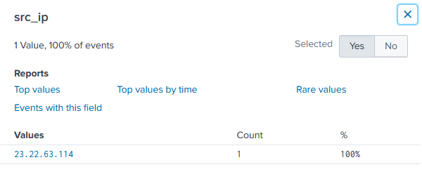

BOTSv1 2.2: Leetspeak Domain (10 pts)
Use a search engine (outside Splunk) to find other domains on the staging server. Search for that IP address. Find a domain with an name in Leetspeak (like "1337sp33k.com").
A: Query: index=botsv1 poisonivy-is-coming-for-you-batman.jpeg http_method=GET
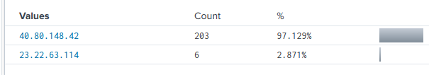
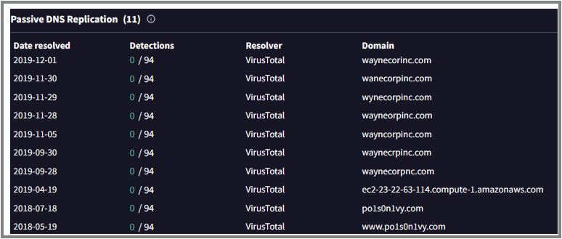
- The other domain on this ip 23.22.63.114 is Po1s0n1vy
- We searched for the leetspeak domain in VirusTotal

BOTSv1 2.3: Brute Force Attack (15 pts)
Find the IP address performing a brute force attack against "imreallynotbatman.com"
Hints: .
- Find the 15,570 HTTP events using the POST method.
- Exclude the events from the vulnerability scanner.
- Examine the form_data of the remaining 441 events.
- To make a useful table, add this to your query:
table _time, form_data
A:
Query: imreallynotbatman.com http_method=POST NOT "Acunetix" form_data="*"
The 23.22.63.114 ip address performing a brute force attack against “imreallynotbatman.com”

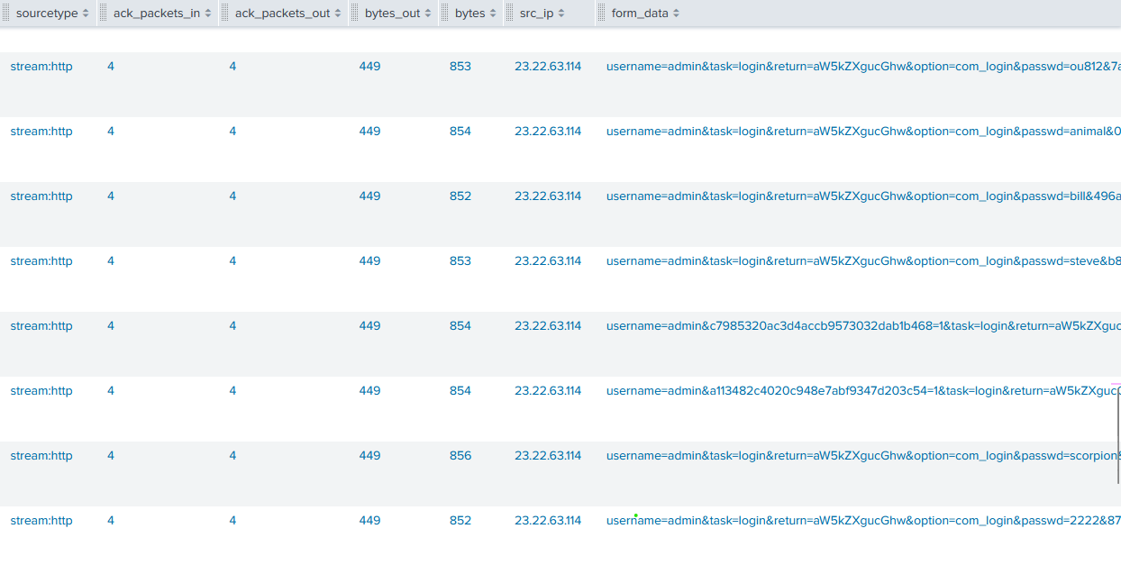
- At a time more than request is there
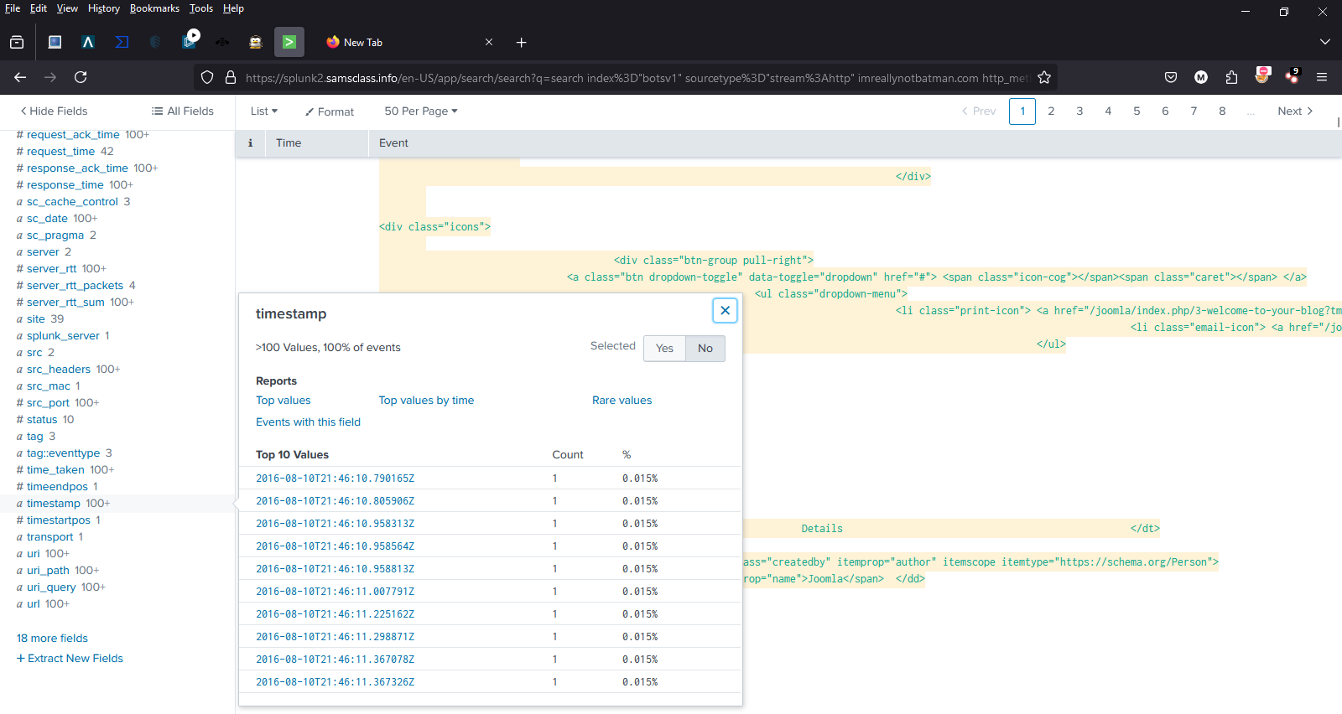

BOTSv1 2.4: Uploaded Executable File Name (15 pts)
Find the name of the executable file the attacker uploaded to the server.
Hints:
- Find the 15,570 HTTP events using the POST method.
- Exclude the events from the vulnerability scanner.
- Search for common Windows executable filename extensions.

A:
Query: imreallynotbatman.com http_method=POST NOT "Acunetix" .exe

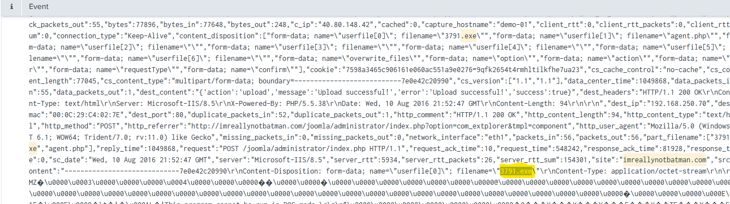

- Filename=3791.exe

